

MSCRM Integration

(MK Denial, Payment Gateway, Email Integration)

**Service Contract**

Contents

**1.** **MK Denial:** 3

**2.** **Payment Gateways:** 7

**3.** **Email Integration:-** 12

1. **MK Denial:**

We invoke the logic utilized in our initial implementation for MSCRM which we utilized for Account or Contact entity with respect to MK Denial web services from CRM. We pass below given parameters from CRM to MK Denial

While in the Pros CPQ Service Implementation we’ll ran the MK denial check during the lead conversion, as soon as the lead gets’ converted to account or contact this will trigger the check.

* Account Name
* Post Code
* Country

Based on above mentioned parameter data this web services check provided Account or Contact data are validated in portal system or Not?

Architecture: -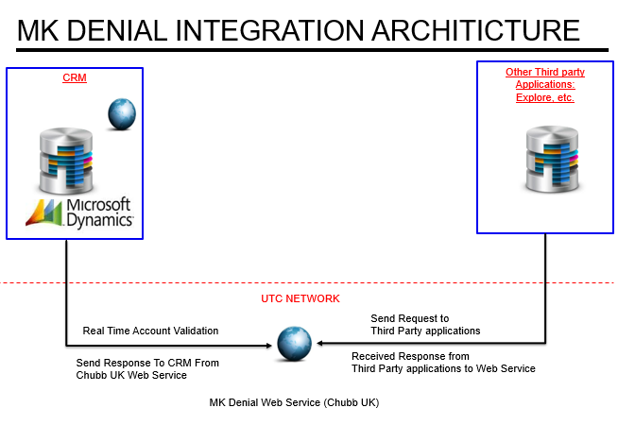

Once the lead gets qualified to account and contact the below steps will be executed sequentially.

MK denial Integration fields on Entity

1. Fields on Account and Contact entities:

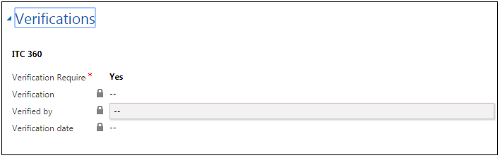

1. MK Denial Integration executed by Clicking on below given button



1. Web Services provide response as “Verification Not Required” then below given data will get updated in CRM

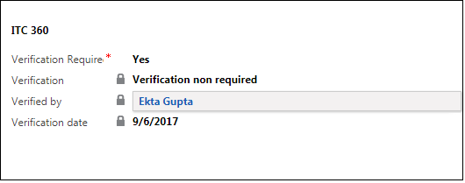

1. Web Services provide response as “Verification Forbidden” then below given data will get updated in CRM

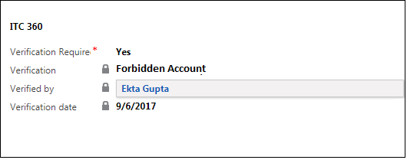

1. If Web Services provide response as “Verification in Progress” then we create one record entry in “ITC 360 Verification Request” entity.

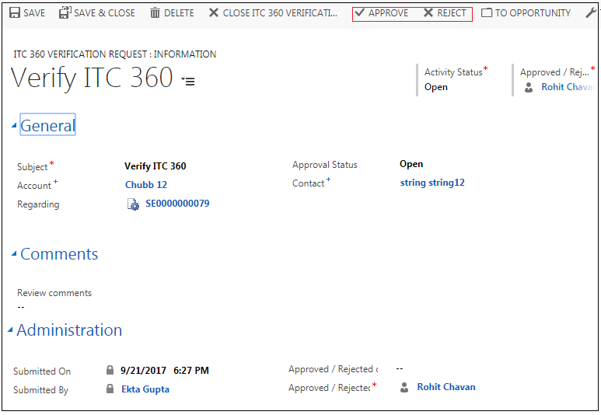

1. When Manger user click on Approve button then associated Account or Contact will get validated in CRM.

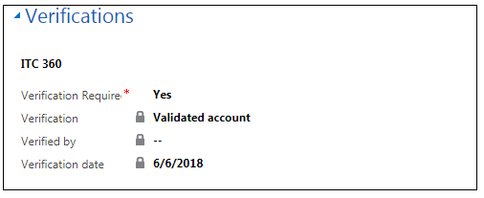

1. When Manger user click on Rejected button then associated Account or Contact will get Rejected in CRM.



1. **Payment Gateways:**

Microsoft Dynamics can seamlessly integrate with SV (Independent Service vendor) offerings- integrating with other suites and applications. CRM often interacts with several back-office applications, including ERP, financial applications, HR apps, content management and file-sharing apps and also Payment Gateway.

Quote, Order & custom entities can easily integrate with the available payment gateways.

**For Pros Service Contract we’ll utilized the Quote entity for processing the payments via gateways.**

1. We depicted Sales order for illustration but, similar process we will adopt for Quote or any other entities within MSCRM especially for our Pros Service Contract implementation.

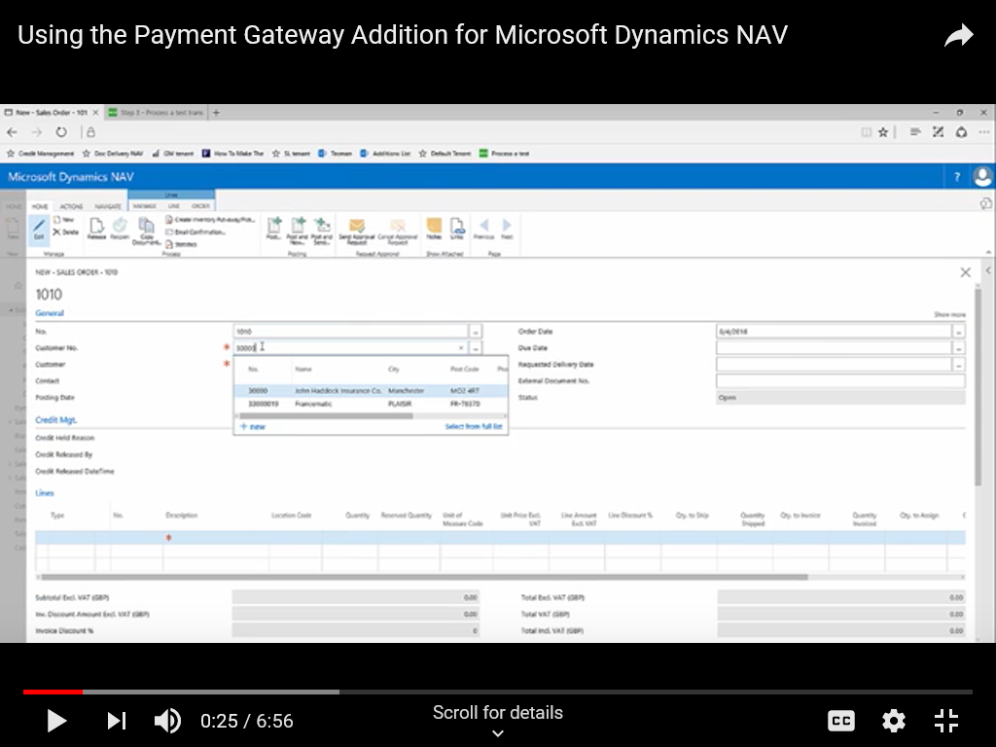

1. Selection of the Payment Method. For Eg: SAGE/ World pay (Used Sage for Illustration Purpose)

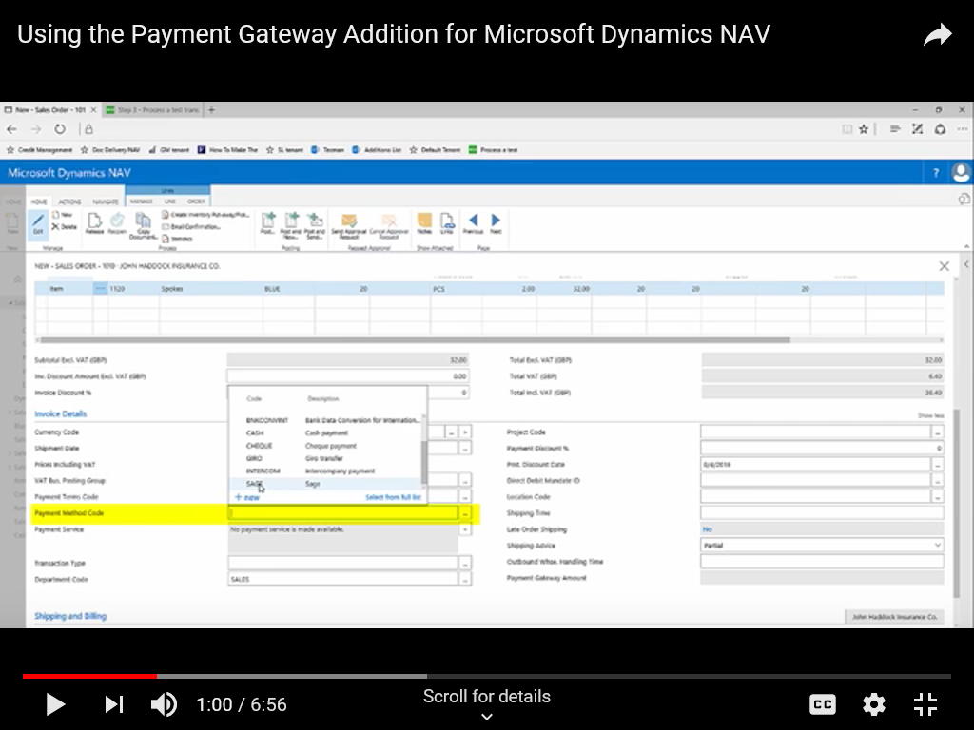

1. Release - Making Payment before the Order is released.

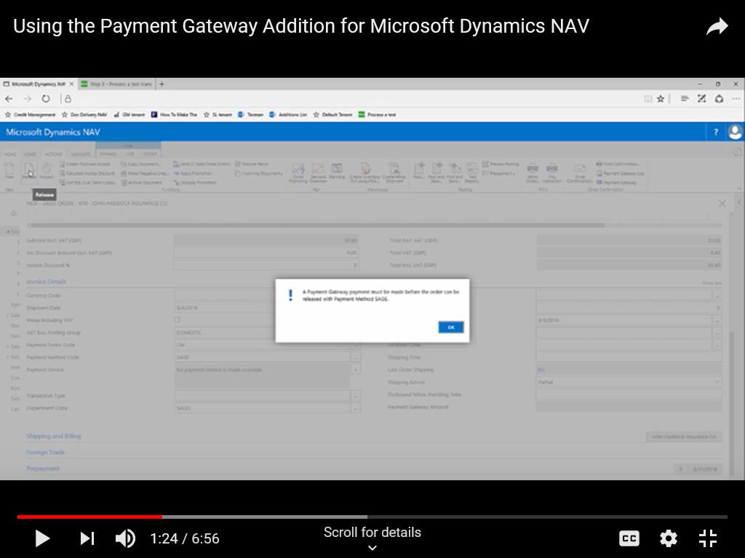

1. Select Payment Gateway

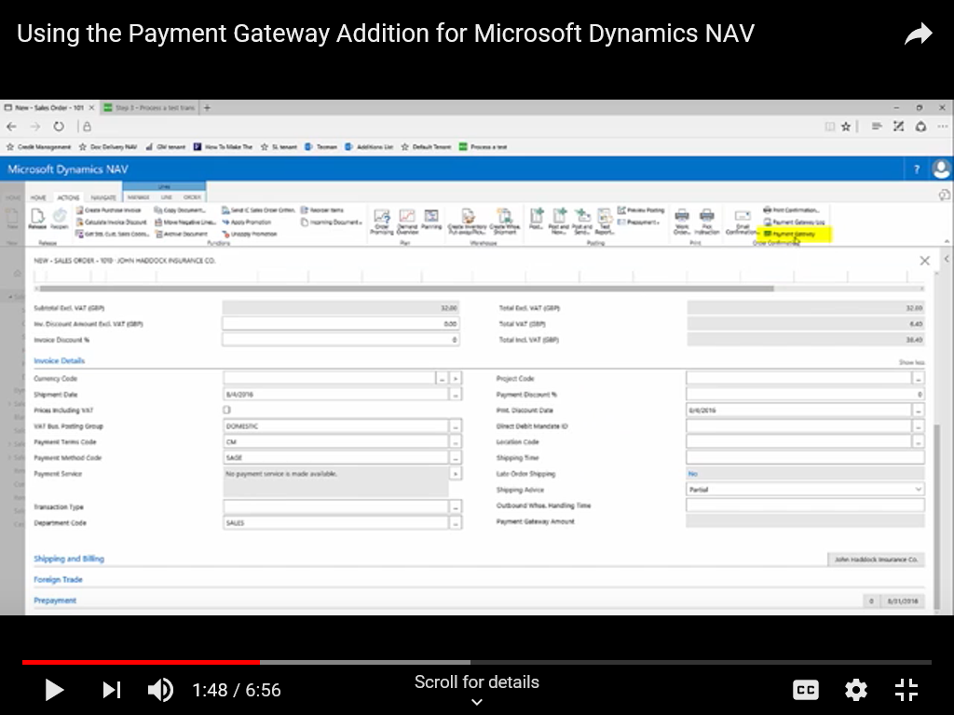- Which displays the billing and payment information.

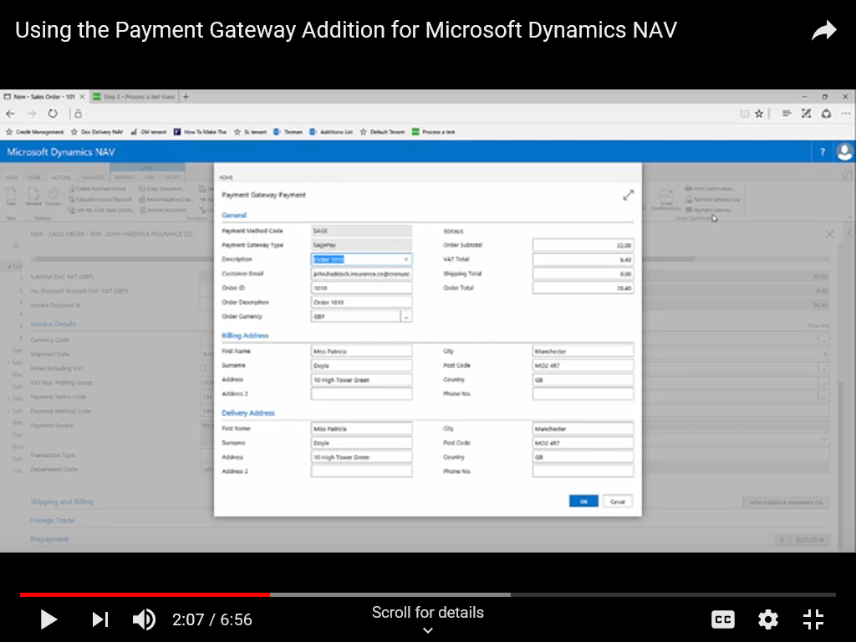

1. Redirected to SAGE payment Website

* Where the necessary details are been entered

For eg: Card no,Expiry mm/yy and etc.

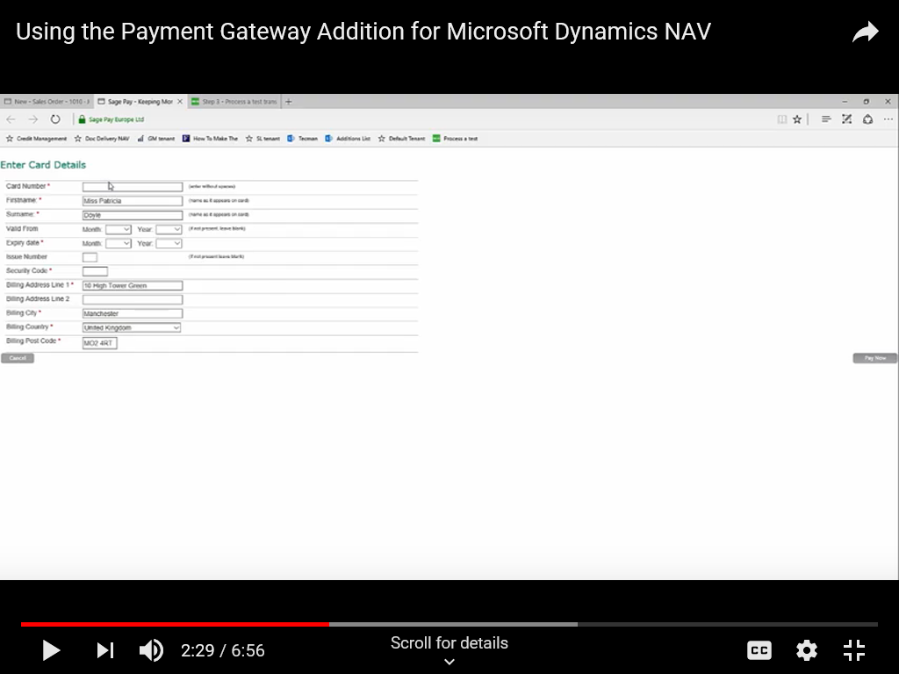

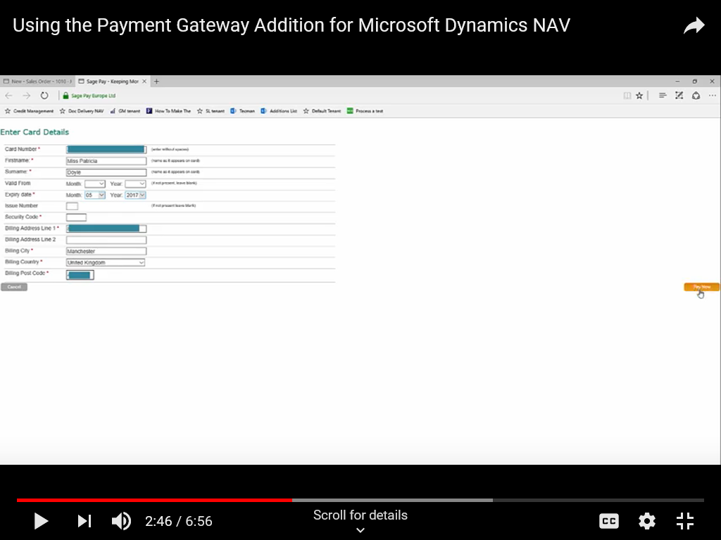

1. After making the payment ,message will be popped saying that the order successful.

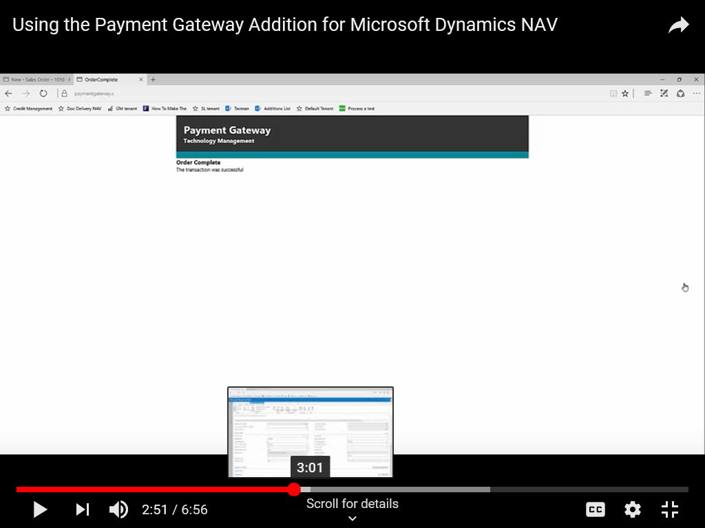

* Payment Gateway Amount Detail

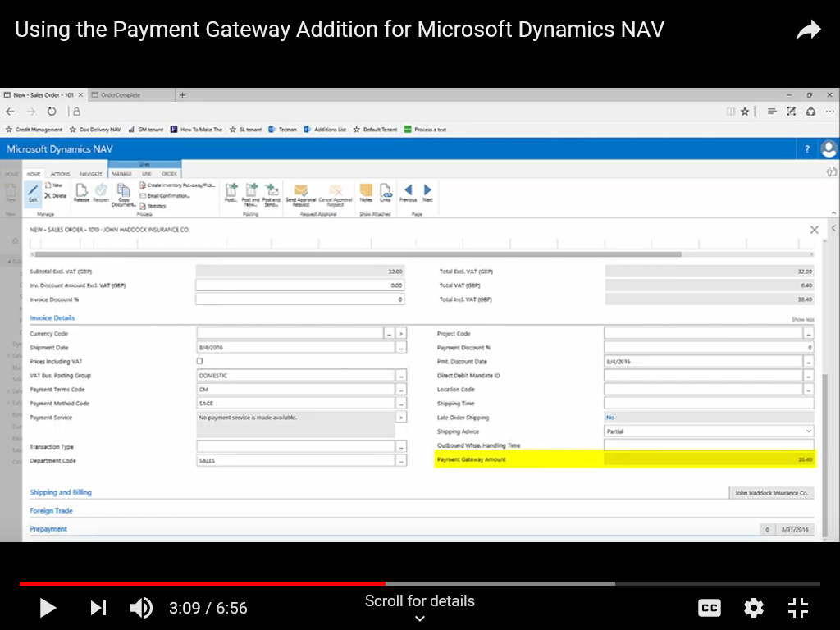

1. For Payment Gateway log.

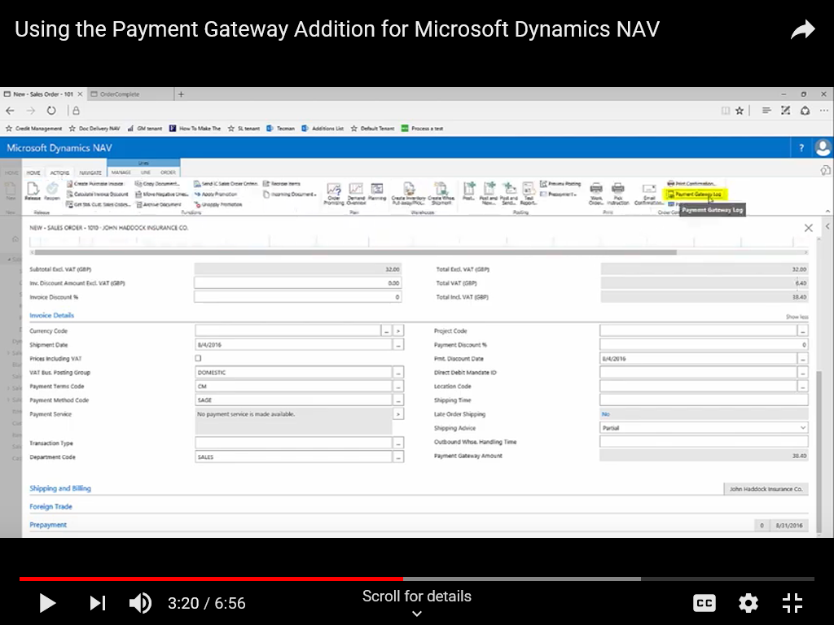

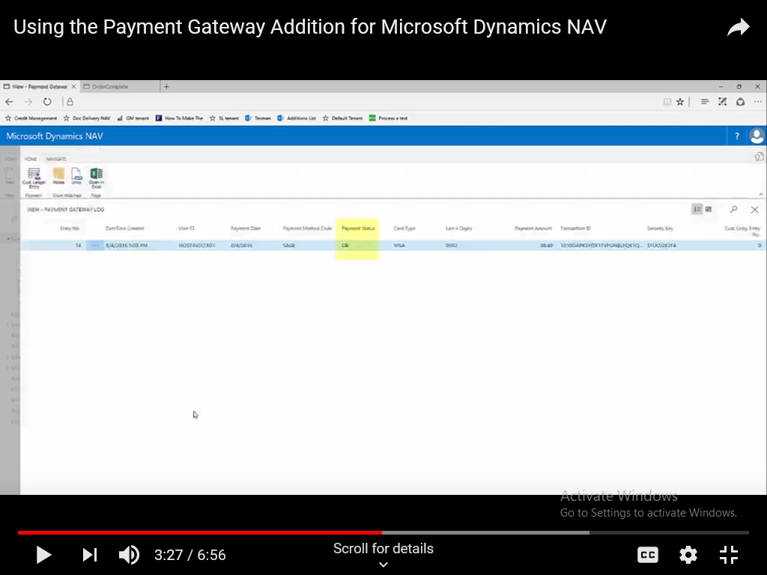

Similar to the Sage we can integrate the Worldpay. Attached



On successful, completion for the payment the sales order /Quote will have statuses updated.

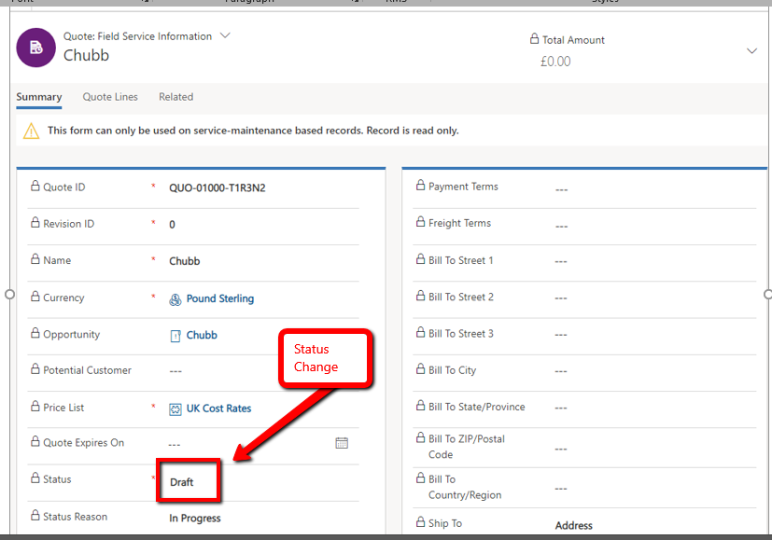

1. **Email Integration: -**

We can utilize the Native Emails feature for the MS CRM within MS Dynamics, to present the quote to the concern parties involved.

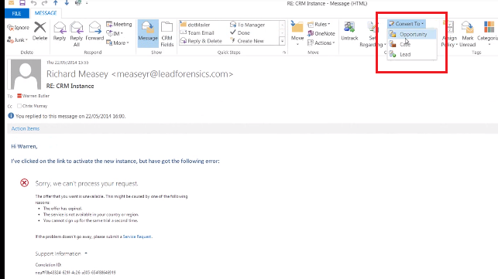

Mail been tracked

